**FOR CUSTOMER ADDRESS**

* GO TO SE16N
* FOR CUSTOMER TABLE ENTER KNA1
* ENTER CUSTOMER NUMBER IN FIELD (KUNNR/CUSTOMER)
* EXECUTE

* COPY THE NUMBER OF ADDRESS FIELD

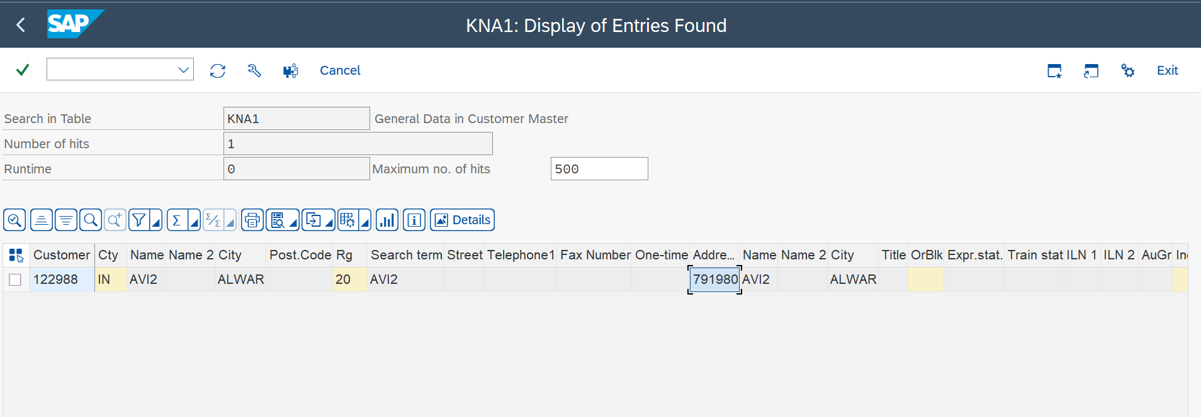

* GO TO TABLE NAME – ADRC
* ENTER THE COPIED NUMBER (FROM CUSTOMER TABLE) IN ADDRESS NUMBER FIELD
* EXECUTE

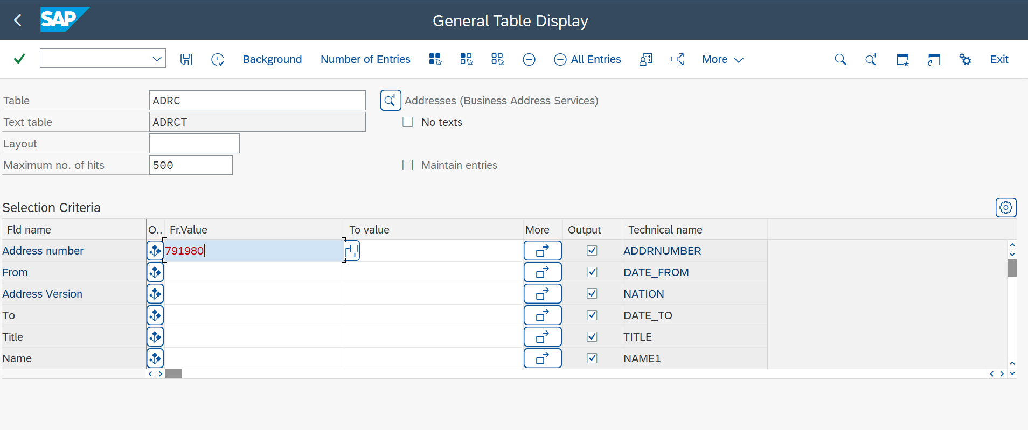

* ADDRESS OF CUSTOMER

**FOR PRICING**

* GO TO VBAK (SALES ORDER DOCUMENT TABLE)
* ENTER THE SALES DOCUMENT NUMBER AND EXECUTE

* COPY THE DOCUMENT CONDITION NUMBER

* GO TO TABLE KONV (FOR DOCUMENT condition)
* ENTER THE COPIED NUMBER IN DOC. CONDITION

* PRICING FROM SALES ORDER DOCUMENT

🡨PRECEDING DOCUMENT

INQUIRY 🡪QUOTATION 🡪SALES ORDER 🡪DELIVERY DOCUMENT🡪BILLING DOC.

FOLLOW ON DOC🡪

**SALES ORDER TO DELIVERY FOR MOVEMENT TYPE**

* GO TO SE16N
* GO TO VBAK (FOR DOCUMENT FLOW)
* ENTER PRECEDING DOC.
* ENTER SUB.DOC.CATEG( J🡪DELIVERY)
* EXECUTE

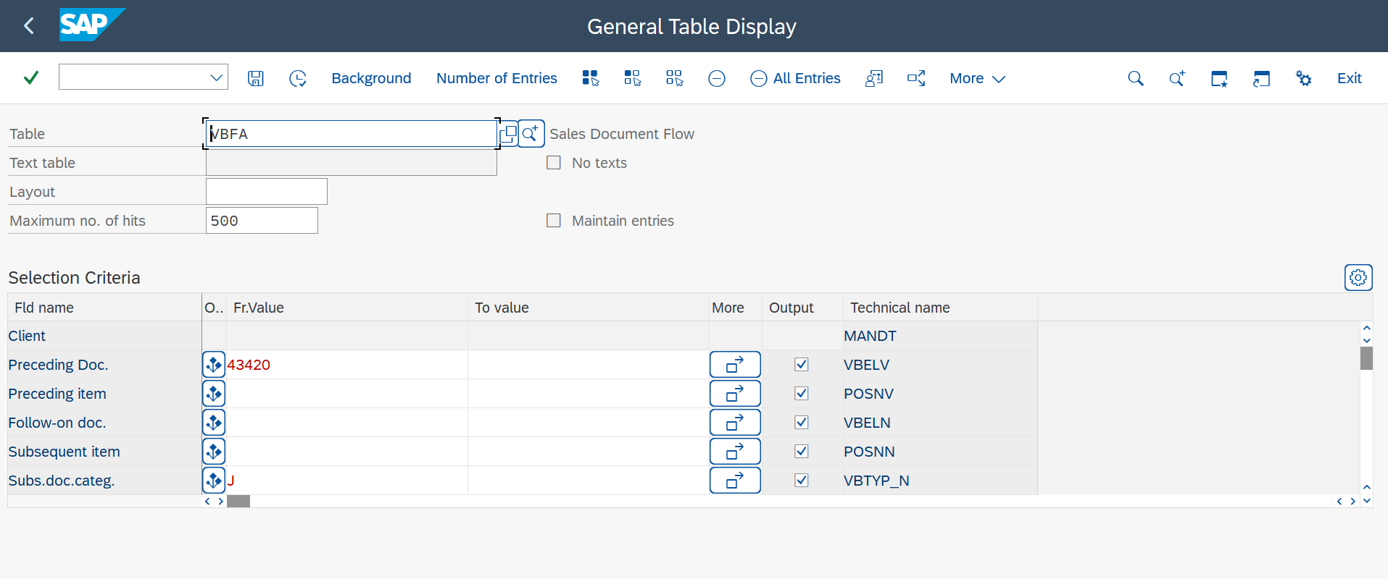

* COPY THE FOLLOWON DOC NUMBER (DELIVERY DOC. NUMBER)

* GO TO LIPS TABLE (FOR DELIVERY DOCUMENT)
* ENTER THE COPIED NUMBER (FOLLOWON DOC NO)
* EXECUTE

* MOVEMENT TYPE

**BILLING DOCUMENT TO SALES ORDER FOR PO NUMBER**

* GO TO TABLE VBFA
* ENTER FOLLOW ON DOC (BILLING DOC NUMBER)
* ENTER PRE. DOC. CATEG. (C =SALES ORDER)
* EXECUTE

* COPY THE PREDECESSOR NO (SALES ORDER NUMBER)

* GO TO TABLE VBAK -SALES ORDER
* ENTER COPIED SALES ORDER NUMBER AND EXECUTE
* PO NUMBER

